detail design document

**"The BB Manager"**

A bibliographies management system , created in order to assist the user in working with different bibliographies and citations in a convenient and efficient way.

System sign: reference:   
Project Manager:   
System Designer:  
Client:  
System maintenance:  
Responsible for maintaining the system:  
Responsible for Manufacturing and operation:  
  
The initiating document written by: date:  
The specification document written by: date:  
Validated and tested by: date:  
participants:

תוכן הענייניםtable of contents

table of contents

table of contents

Goals and purpose ..3

Administration ..4

Goals ..5

implementation ..7

**Technology and infrastructure………………..………………………………………...10**

execution 12

**cost – resources………………………………………………………………….………..14**

appendix 15

# Goals

* 1. **Goals and Purposes** 
     1. General goals
     2. Practical purposes
     3. Future purposes
  2. **Problems**
     1. Problems that the system should solve
     2. Problems that the system may create
  3. **Applicability and cost\profits**
     1. Risks – applicability of the project

1. **GENERAL ARCHITECTURE**
   1. **General features**
      1. Current state
      2. The system's nature
      3. Limitations
      4. Glossary
   2. **External binding**
      1. General binding
      2. Users
      3. Acquiring systems
   3. **Internal binding**
      1. General description of the system
   4. **User interface**
      1. General ergonomics
      2. Tree of screens
      3. Operation screens
   5. **Processes** 
      1. General index
      2. Name of process
   6. **Transactions**
      1. General index
      2. Transaction x
   7. **Modules**
      1. Source modules
      2. Executable modules
   8. **Control procedures**
   9. **Routines**
      1. Local routines
      2. Routine x
      3. Third party routines
   10. **Input (forms)**
   11. **Information security**
       1. General – clarifications
       2. Information security risks
       3. Information security tools
       4. Security management
   12. **Interfaces and links**
       1. Index and general list
       2. Interface x
   13. **Special demands**
   14. **Future demands**
2. **GENERAL ARCHITECTURE**
   1. **Main hardware**
   2. **Main data storage**
   3. **Shelf programs** 
      1. Service programs
      2. implementation programs
3. GOALS  
   in this section the project's goals and expectations from the overall system is presented. There is a separation between the general goals of the project and the practical purposes.  
   1. Goals and purposes
      1. General goals   
         The goals are described in the following table :

|  |  |
| --- | --- |
| MAIN GOALS | SECONDARY GOALS |
| Creating a data base based on the API | Building an easy and effective software for the user to handle |
| Editing information in the data base | Allowing the user a convenient work environment |
|  |  |

* + 1. Practical purposes   
       The purposes of the system are described in the following list by order (from the most important to the least important) :
* Adding new information to the data base
* Erasing information from the data base
* Updating information in the data base
* Printing information from the data base (check if the Format in Publishing date is USA or IL and print by the Foromat)
* Exporting information from the data base to another format

* 1. Problems
     1. Problems that the system should solve

|  |  |  |  |
| --- | --- | --- | --- |
| cause | problem | solution | priority |
| Workload assignments | The user cant remember if he finished the work on a project | The projects are categorized (active\projected\archived) | high |
| Lack of organization | The user cant find old bibliographies and citations | The application organize all of the projects and the citations by order | high |
| Not knowing the sources | The user doesn’t know where the citation is from | The ability to Search a citation by different parameters | medium |
| Working in continuity | The user cant remember what were his plans for the project | The ability to add personal notes to a project at any time | medium |
| Secured projects | The user cant use the information inside the project for other purposes | The application allows exporting a project or citations | medium |
| Configuration | The user needs to adjust the project to different demands | The ability to choose a format for the project | medium |
| Work demands | The user needs to use information he once already used before | The option of editing an existing project or citation | High |
| Security | The user wants to work on his bibliographies in a private space | The application requires a personal password that the user may choose for himself | high |
|  |  |  |  |

* + 1. Problems that the system may create

|  |  |  |
| --- | --- | --- |
| cause | problem | type |
| No internet connection | The system doesn’t work | Technical issue |
| The user forgot the password | No access to the system | Functionality |
| The user deleted a citation\project by mistake | The citation\project must be inserted again | Functionality |
|  |  |  |

* 1. **Applicability and cost\profits**
     1. Risks – applicability of the project

1. **GENERAL ARCHITECTURE**
   1. **General features**
      1. **Current state**

The current stage of the system is in process. We are developing the functions of the software while working with API and creating a data base for the application.

* + 1. **The system's nature**The system is a new self-developed product , that has no connection to other systems available in the market**.**the system's type is partly information center and partly operative system because of the options that the application offers to the user. There is the option of operating in the application (creating\editing new projects\citations , adding notes, exporting to text file , etc.) , as well as the option of browsing in the archive without changing the information.  
       The activity type in the system is data entry since the application allows the user to insert the wanted information.
    2. **Limitations**

The main limitations of the project are :   
- the application is internet based (technical environment)  
- the citations included in the projects may cause an issue of copyrights (legal issue)

* + 1. Glossary
* Data base – a comprehensive collection of related data organized for convenient access, generally in a computer.
* API – a set of protocols used by programmers to create applications for a specific operating system or to interface between the different modules of an application.
* Citation – the act of citing or quoting a reference to an authority.
* Export - to save (documents, data, etc.) in a format usable by another software program.

**2.2. External binding**

2.2.1. **General binding** The product is a web-based application , that works without

interfacingwith other systems.  
the system's use and the general workflow of the application is presented inside the DFD diagram.

* + 1. **Users**

The intended users of this application are:

* Project managers
* Testers
* Documentation writers
* Developers
* Students
  + 1. **Acquiring systems**

the system does not interface with any other system in the market.  
It is an application that works in an API environment and relies on web connection.

* 1. **Internal binding**
     1. **General description of the system**

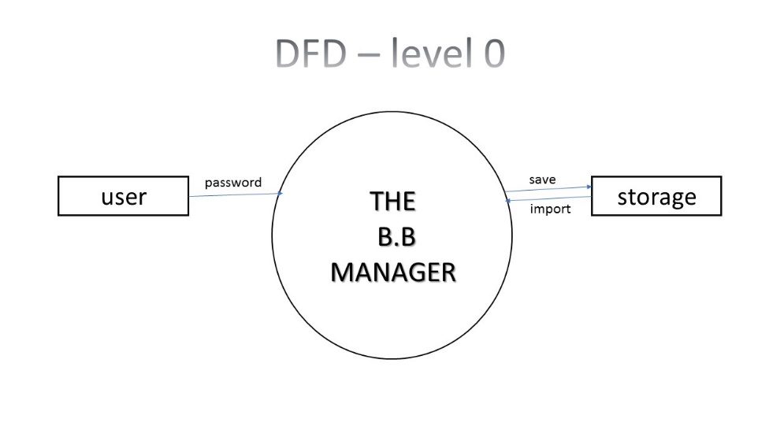

The system is a bibliography management tool that was created in order to assist the user with handling documents and storing them for further use. The application works based on API data base rules , as well as web connection.  
basically , the user is provided with access to the system threw a password of his choice (for security), after entering the system there are multiple options for managing the documents that are stored inside the data base. The user can use the application services as long as he is logged in to the system.  
The system's functionality will be explained with more details in this design document.

* 1. **User interface**
     1. **General ergonomics**The system is working based on API data base, under the web- restrictions and conventions.
     2. **Tree of screens**In this section a diagram is added in order to present the available options of the application:

LOGIN

CHANGE PASSWORD

HELP

Unit Tests

Add new project

Add category

Edit project

Edit category

Delete project

Add citation

Delete category

Export

Edit citation

Delete citation

IEEE

MLA

Harvard

APA

Print

Print category citations

Print all projects

Print categories

Print all citations

Print project citations

HELP

* + 1. **operation screens**the operations will be demonstrated in a diagram as well:

The user must type "-h" or "—help" in order to use this option

Printing a massage

The user must type "-cp" or "—changepassword" in order to use this option

Creating a new password

CHANGE PASSWORD

The user must type "-li" or "—login" in order to enter the system. Format-'<python tbbm.py -li <password'

The user may choose an option from the menu displayed in the previous page (tree of screens)

LOGIN

The user must type "-lo" or "—logout" in order to exit from the system

LOG OUT

Exit the system

The user must type "-ut" or "—unittest" in order to perform the tests

Runs the tests

Unit Tests

After login into the system the following options are available :

To choose this option the user must type -python tbbm.py -ap (or --addProject) n: "Project Name"

while "n:" is used to mark the name of the project

A new project is created

Add new project

To choose this option the user must type -

python tbbm.py -ep (or --editProject) id: <id> pn: "Updated Name"

while "<id>" is the id of the project you want to update

or

python tbbm.py -ep (or --editProject) id: <id> s: "Updated State"

while "s:" is to mark the state of your project (Active/Projected/Archived)

Enter the relevance change in the selected project

Edit project

The project is deleted

To choose this option the user must type -

python tbbm.py -dp (or --deleteProject) id: <id>

while "<id>" is the id of the project you want to delete

Delete project

The citation is being added according to the information the user enters

Add citation

To choose this option the user must type -

python tbbm.py -ac (or --addCitation) <mark1>: <value1> <mark2>: <value2> ...

the list of the marks you can use

"s:" - source type (Available source types are: Book, Journal, Newspaper, Online, Magazine)

"pid:" - the ID(s) of the project(s) that the citation is related to (for example pid: "1 2 3 4")

"t:"- title

"fn:" - main author's first name

"ln:" - main author's last name

"cid:" - the ID(s) of the category(ies) that the citation is relevant to

"f:" - will the file appear in the final version (use true/false only )

"n:" - a note

"y:" - publishing year

"pub:" - publisher (optionally)

When the user want to add release date of the Citations he need to choose Format (USA/IL) (update by Guy Hassan)

"m:" - publishing month (optionally)

"d:" - publishing day (optionally)

"ps:" - from page __ (optionally)

"pe:" - to page __ (optionally)

"u:" - URL (optionally)

"sfn:" - secondary author's first name (optionally)

"sln:" - secondary author's last name (optionally)

The category is changed according to the information inserted by the user

To choose this option the user must type -

python tbbm.py -ecat (or --editCategory) id: <id> catn: "Updated Name"

while "<id>" is the id of the Category you want to update

Edit category

New category is available

To choose this option the user must type -

python tbbm.py -acat (or --addCategory) n: "Category Name"

while "n:" is used to mark the name of the category

Add category

The citation is deleted

The citation is being changed according to the information the user enters

To choose this option the user must type -

python tbbm.py -ec (or --editCitation) id: <id> <mark>: <new_value>

while "<id>" is the id of the citation you want to update

and "<mark>" is the mark of the field you want to update

Edit citation

To choose this option the user must type -

python tbbm.py -dc (or --deleteCitation) id: <id>

while "<id>" is the id of the citation you would like to delete

Delete citation

To choose this option the user must type -

python tbbm.py -eapa (or --exportAPA) <id>

while <id> is the id of the project you would like to export in APA format

To choose this option the user must type -

python tbbm.py -eh (or --exportHarvard) <id>

while <id> is the id of the project you would like to export in Harvard format

To choose this option the user must type -

python tbbm.py -emla (or --exportMLA) <id>

while <id> is the id of the project you would like to export in MLA format

To choose this option the user must type -

python tbbm.py -eieee (or --exportIEEE) <id>

while <id> is the id of the project you would like to export in IEEE format

IEEE format

Harvard format

MLA format

APA format

Export

The category is deleted

To choose this option the user must type -

python tbbm.py -dcat (or --deleteCategory) id: <id>

while "<id>" is the id of the category you want to delete

Delete category

* 1. **Information security**
     1. General – clarifications   
        This system is a non- classified system for private use.  
        the security of the information kept inside the application is being guarded by a personal password that the user created for himself.  
        There is no danger for anyone if the information will reveal, but the privacy is provided by the password.
     2. Information security risks  
        The security risks that may happen in this system are :  
        - A different person enters to the user's account (knowing the password)  
        - The password is not complicated enough (there is a risk that someone will break into the account)  
        - The information kept in the data base is open to other sources   
        non of the risks above is dangerous to the user or to any other entity, as well as the environment and the system itself. The risks are minor and only effects the privacy of the user,. the app stores bibliographies and not classified information of any sort so there is no risk of important delicate data leak.
     3. Information security tools  
        In order to enter the system , the user must create a personal password that is going to allow access to the app for further use.  
        other then the password that the user chooses for his account there are no other security limitations in the system.  
        as mentioned before, the information stored in the data base is not classified and does not require any security measures.
     4. Security management   
        * accounts management – personal password for every new user (account)  
        * the app's services are available for the user as long as he didn’t log out of the system
  2. **Interfaces and links**
     1. Index and general list   
        - The name of the system : "The BB Manager"   
        - Connection type : web based ,information storage application  
        - The type of the system : self – developed, first addition   
        - A non-classified system for bibliography documents management
     2. Interface x  
        The system does not interface with any other system, it is a web-based application that does not require services from different systems.

* 1. **Special demands**
* Flexibility :  
  - The system is web-based , meaning that the web connection is necessary for the activation of the system. Without internet connection the application does not work.  
  - The system works with API data base.  
  - The user must work on the application according to the instructions presented in the help section inside the app.
* Portability :  
  - The system works with API fire base, the code and the overall functionality of the system depends on the data-base.  
  - The system is web-based , meaning that every platform that has web connection is able to enter the application and use it ( computers ,phones , ipads , etc. ).
* Languages :  
  - The system is available in English , the instructions and all of the options provided by the application are in the English language .
  1. **Future demands**
* Allowing access to the system without web connection
* Allowing the user to choose the language comfortable for him